Constraint-First STA Sprint (RTL -> Synth -> STA on a Small Block)

Project Aim
Learn the end-to-end timing-analysis mindset used in real Physical Design and STA roles: you start with a small synchronous RTL block, synthesize it to gates, write realistic SDC constraints, and then use OpenSTA to answer the questions that matter in industry (What is the critical path? Do we meet setup and hold? What changes improve slack?).
Market value: constraints and report-reading are core skills for STA/PD job descriptions; teams rely on engineers who can quickly diagnose slack issues and communicate root cause clearly.
Personal growth: you build intuition for clocks, uncertainty, IO assumptions, and why a design that simulates correctly can still fail timing.

Tools & Skills Required
- Verilog/SystemVerilog - Write the synchronous RTL block and (optional) a simple testbench; keeps the project close to how blocks enter a PD flow.
- Yosys - Open-source synthesis to create a gate-level netlist and show how RTL structure maps to logic depth and registers.
- OpenSTA - Static Timing Analysis engine to apply SDC constraints and produce setup/hold timing reports.
- Sky130 standard-cell Liberty (.lib) - Provides realistic gate delays and timing arcs so STA results reflect a real technology library.
- GTKWave (optional) - View RTL simulation waveforms to confirm functional correctness before timing work.
- Checkpointing (recommended) - Version changes to RTL and constraints; makes timing experiments reproducible and easy to compare.

Detailed Description
This project focuses on developing a minimal yet industry-relevant Static Timing Analysis (STA) workflow centered around a single-clock digital design block. The design consists of a small datapath structure with a well-defined critical path, such as a registered arithmetic or multi-stage datapath unit. The primary objective is to understand how timing behavior is analyzed, validated, and communicated rather than to develop a large or complex system.
The workflow begins with verifying functional correctness through simulation to ensure that the design produces the expected outputs over multiple clock cycles. After functional validation, the Register Transfer Level (RTL) design is synthesized using Yosys to generate a gate-level netlist. The gate-level netlist serves as the foundation for timing analysis since STA is performed on synthesized or physically implemented netlists rather than behavioral RTL descriptions.
An essential component of the workflow involves developing a Synopsys Design Constraints (SDC) file. The SDC defines timing assumptions for the design, including clock period, clock uncertainty, and input/output timing delays. These constraints model the external environment surrounding the design, such as upstream logic, interface timing requirements, and clock quality. Static timing analysis is then performed using OpenSTA to generate setup and hold timing reports. The analysis includes identification of critical paths, examination of arrival and required times, and evaluation of slack calculations.
The project also includes controlled constraint variation experiments to study timing sensitivity. Individual parameters such as clock period, clock uncertainty, and input/output delays are modified systematically to observe their impact on Worst Negative Slack (WNS), Total Negative Slack (TNS), and critical path characteristics. The final outcome presents a structured timing analysis summary describing the dominant critical path, factors influencing timing performance, and potential optimization strategies such as pipelining, constraint refinement, or synthesis improvements.

Design Architecture / Block Diagram
+-----------------------------+
Inputs (a,b,op) --->| Combinational Datapath |----> comb_result[N-1:0]
| (adder / logic / shifter) |
+--------------+--------------+
|
v
+---------+
clk ------------------------->| Reg FF |----> result[N-1:0]
rst ------------------------->| |
enable (optional) ----------->| (CE) |
+---------+

STA FLOW (what you build)
-------------------------
RTL (Verilog)
|
v
Yosys Synthesis --> Gate Netlist (.v) + Stats
|
v
Liberty (.lib) + Constraints (.sdc)
|
v
OpenSTA
|
+--> report_checks (setup/hold)
+--> WNS / TNS
+--> Critical path breakdown

Pre-flight knowledge

Synthesis and Its Role Before STA
Synthesis is the process of converting a high-level hardware description written in RTL (such as Verilog or VHDL) into a gate-level netlist made of standard cells like logic gates and flip-flops. During synthesis, the tool maps the design to real hardware elements from a technology library and optimizes it for goals such as timing, area, and power.
Static Timing Analysis (STA) must be performed after synthesis because accurate timing checks require knowledge of actual gates, their delays, and how they are connected. Without synthesis, timing analysis would be based on abstract logic rather than real hardware delays, making STA results meaningless.

Timing basics
- What is a clock period (e.g., 10 ns = 100 MHz)?
The clock period is the amount of time between two consecutive active clock edges (usually rising edges). It defines how much time the circuit has to perform one operation. For example, a clock period of 10 ns means the clock ticks every 10 nanoseconds. The clock period sets the overall speed of the digital system. Shorter periods mean faster operation but tighter timing requirements.
- What is the difference between setup and hold (max vs min timing checks)?
Setup and hold times are timing requirements of flip-flops that ensure data is captured correctly.
Setup time is a maximum timing check, which means data must arrive at the destination flip-flop before the clock edge by a certain amount of time. If data arrives too late, a setup violation occurs.
Hold time is a minimum timing check, which means data must remain stable after the clock edge for a short duration. If data changes too early, a hold violation occurs.
In simple terms, setup checks prevent data from being too slow, while hold checks prevent data from being too fast.
- What is a register-to-register path (launch FF -> logic -> capture FF)?
A register-to-register path is the most common timing path in a synchronous digital design. It starts at a launch flip-flop, where data is launched on a clock edge, then passes through combinational logic, and finally ends at a capture flip-flop, where the data is captured on the next clock edge.
Static Timing Analysis (STA) checks whether the data can travel through this path within the allowed clock period while meeting setup and hold requirements.
- What is Slack (required time minus arrival time)?
Slack is a measure of how safe or unsafe a timing path is.
It is calculated as required time minus arrival time. Required time is the latest time data is allowed to arrive, and arrival time is when the data actually arrives.
If slack is positive, the timing requirement is met, and the path has extra margin. If slack is negative, the path fails timing and may cause incorrect behavior.
Slack helps designers quickly identify critical and failing paths.
- What are Worst Negative Slack (WNS) and Total Negative Slack (TNS)?
Worst Negative Slack (WNS): WNS is the largest timing violation in a design, representing the most negative slack among all timing paths. Slack is the difference between the required arrival time and the actual arrival time of a signal. If WNS is negative, it indicates that at least one path fails to meet timing requirements, and the absolute value shows by how much it misses the target.
Total Negative Slack (TNS): TNS is the sum of all negative slacks across the design. It gives an overall measure of timing violations, showing how much total timing adjustment would be needed to fix all failing paths. A high TNS indicates widespread timing problems, while a low TNS may indicate only a few critical violations.

STA / constraints
- What is create_clock and why does STA need it?
The create_clock command defines the clock used in the design, including its period and waveform. STA tools need this information to know when data is launched and when it must be captured. Without a defined clock, the timing tool cannot calculate setup and hold checks or determine required times.
In essence, create_clock tells STA how fast the design is supposed to run and forms the foundation of all timing analysis.

- What does input_delay / output_delay represent (timing budget to/from surrounding logic)?
Input delay and output delay represent the timing relationship between the design and the surrounding external logic. Input delay specifies how much time external logic takes to provide valid input data after the clock edge. Output delay specifies how much time external logic requires to capture output data. These constraints allow STA to reserve part of the clock period for logic outside the chip or block, ensuring the entire system meets timing, not just the internal design.

- What is clock uncertainty (jitter/skew/margin)?
Clock uncertainty accounts for variations in the clock signal due to jitter, skew, and design margins. Jitter refers to small variations in clock edge timing over time, while skew refers to differences in clock arrival times at different flip-flops. STA includes clock uncertainty to be conservative, reducing the available time for data paths. This helps ensure the design works reliably under real-world conditions rather than ideal simulations.

- Why can a design simulate correctly but still fail timing?
Functional simulation checks logical correctness, assuming signals change instantly or with ideal delays. However, it does not accurately model real delays caused by gates, wires, and clock distribution.
STA, on the other hand, analyzes actual delays based on the physical implementation. A design may simulate correctly but fail timing if data arrives too late or too early in real hardware.
This is why passing simulation alone is not enough, timing closure is essential for a working silicon design.

Environment Setup
Operating System: Windows with WSL2
Linux Distribution: Ubuntu
Editor: Visual Studio Code (Remote-WSL)
- Start -> search: Turn Windows features on or off.
- Enable: Windows Subsystem for Linux AND Virtual Machine Platform.
- Restart the PC.
Windows Features showing WSL enabled:
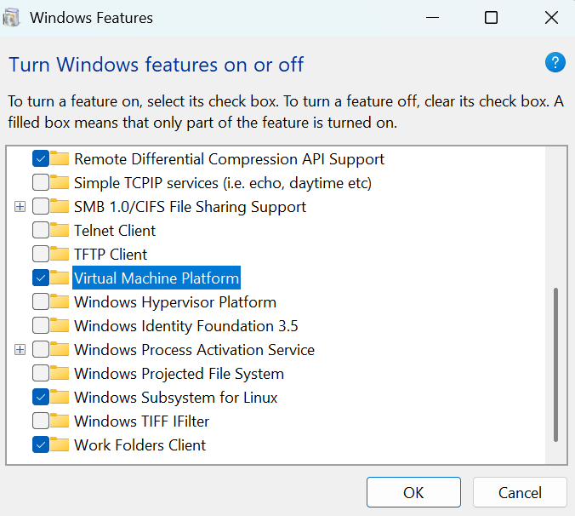

- Open Microsoft Store -> search Ubuntu -> install Ubuntu 22.04 LTS (or 20.04 LTS).
- Launch Ubuntu -> create a UNIX username and password (your Linux login).
Ubuntu opened successfully:
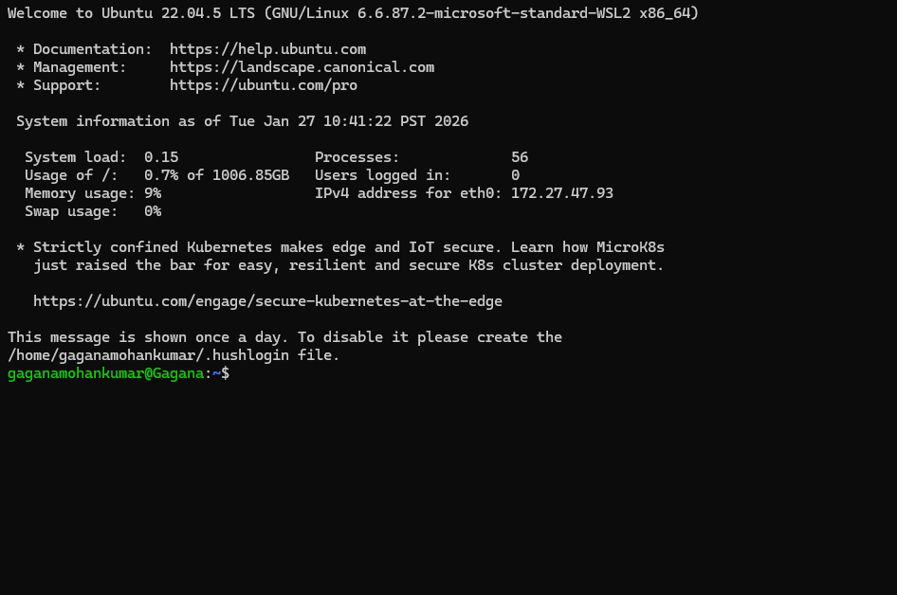
- Install VS Code on Windows.
- In VS Code -> Extensions -> install: WSL (Microsoft).
- Open Ubuntu terminal -> run: code . (first time installing VS Code server).
VS Code Remote - WSL
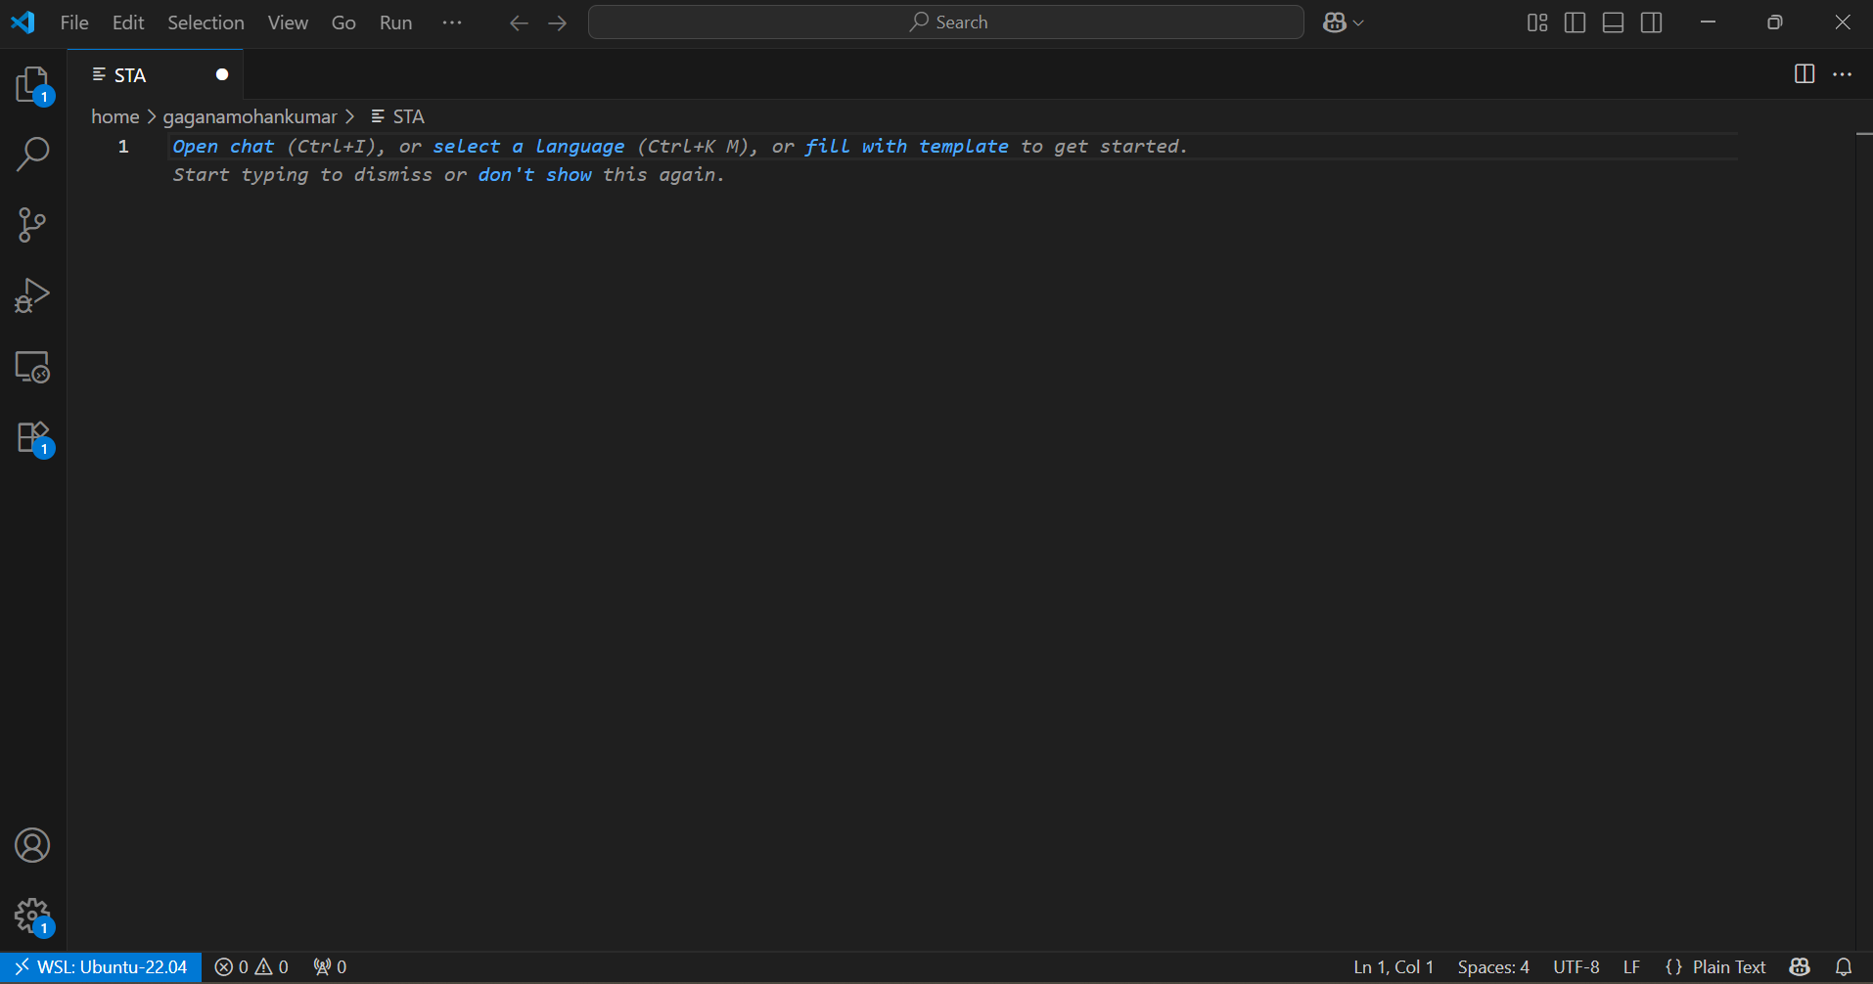
Install tools in WSL (Yosys, OpenSTA, simulator)
Update packages
sudo apt update
sudo apt -y upgrade
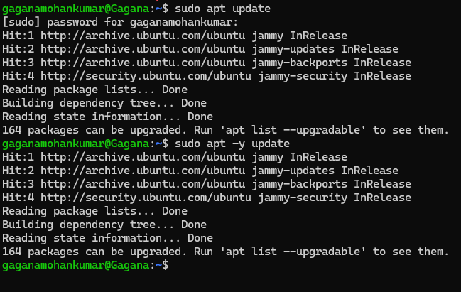

Install Yosys + OpenSTA + basic helpers
sudo apt -y install yosys opensta
sudo apt -y install iverilog gtkwave
sudo apt -y install make python3 python3-pip
Terminal output with tool versions.
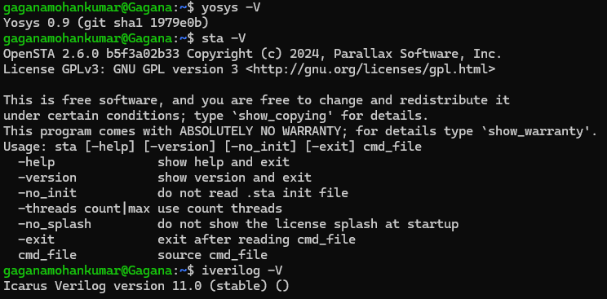

Get a Sky130 standard-cell Liberty (.lib) file (you can explain about this library)
- If you already have OpenLane installed: locate the .lib inside the OpenLane PDK folders and copy it into your project.
- If you do not have OpenLane installed: download an OpenLane release ZIP (no git clone), extract it, then copy the liberty file.
Find it:
sudo find / -name "sky130_fd_sc_hd__tt_025C_1v80.lib" 2>/dev/null | head
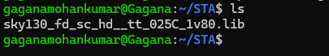

The Sky130 standard-cell Liberty library is an open source technology library that provides detailed timing, power, and functional information for standard cells used in the SkyWater 130 nm process. It includes logic gates, flip-flops, buffers, and other commonly used digital building blocks, each characterized with accurate delay and power models. The Liberty (.lib) file contains timing parameters such as cell delays, setup and hold times, transition times, and power data, which are used by synthesis and Static Timing Analysis (STA) tools.
During synthesis, the RTL design is mapped to these standard cells, and during STA, the delay values from the Liberty library are used to compute accurate timing results. Without this library, tools would not know the real hardware characteristics of the gates, making synthesis and timing analysis impossible.

Project Workspace
mkdir
-p sta_sprint/{rtl,tb,scripts,constraints,lib,build,reports,notes}
cd sta_sprint
ls -R
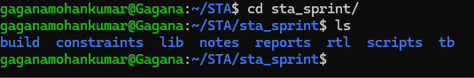
Folder tree in VS Code:
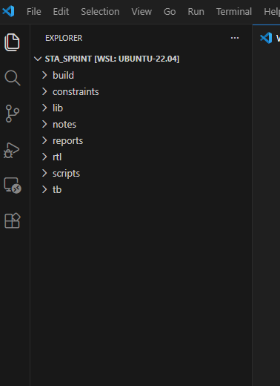

Recording_templete.md file created:
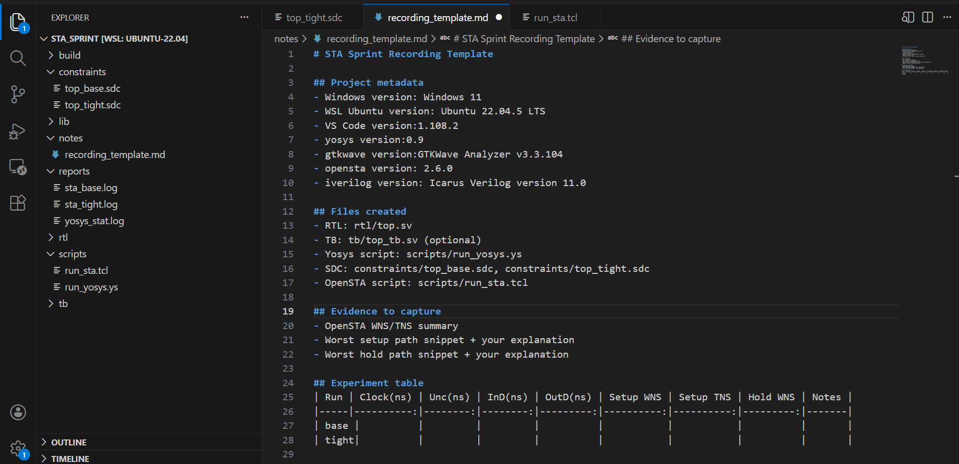
Copy the Sky130 liberty into /lib
cp /path/to/sky130_fd_sc_hd__tt_025C_1v80.lib .(Maybe you can add why we are doing this step
ls

The Liberty (.lib) file is copied into the project directory to ensure consistent and controlled access to the technology timing models during synthesis and Static Timing Analysis.
This approach also ensures that the same characterized timing data is used across synthesis and STA runs, avoiding mismatches that could affect timing results. Keeping the library file within the project directory improves portability and makes the design setup easier to share or archive.

Implement the DUT (small block)

Create rtl/top.sv (registered ALU slice)(Can you explain the code)
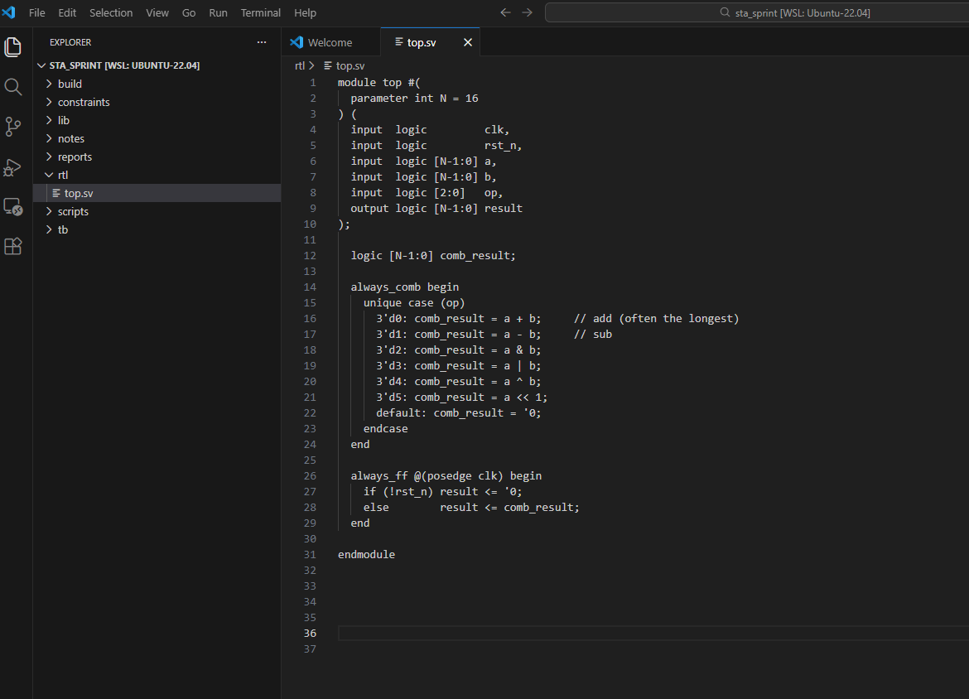

- The top module implements a parameterized 16-bit synchronous ALU controlled by a 3-bit operation select signal (op).
- It performs arithmetic operations (addition and subtraction) and logical operations (AND, OR, XOR, left shift) using a combinational always_comb block.
- The intermediate result (comb_result) is registered on the rising edge of the clock using an always_ff block, making the output synchronous.
- An active-low reset (rst_n) initializes the output register to zero.
- The combinational ALU logic between the inputs and the output register forms the main timing path analyzed during synthesis and Static Timing Analysis.

Quick Lint check:
iverilog -g2012 -o build/lint.out rtl/top.sv(can you state the purpose of this and what did you find)
The design is compiled using Icarus Verilog with SystemVerilog-2012 support to perform a syntax and structural validation of the RTL code. This step acts as a lightweight linting process to ensure that the RTL code is free of syntax errors, undeclared signals, mismatched widths, or unsupported constructs. Running this check early in the flow helps detect coding issues before proceeding to more complex stages.
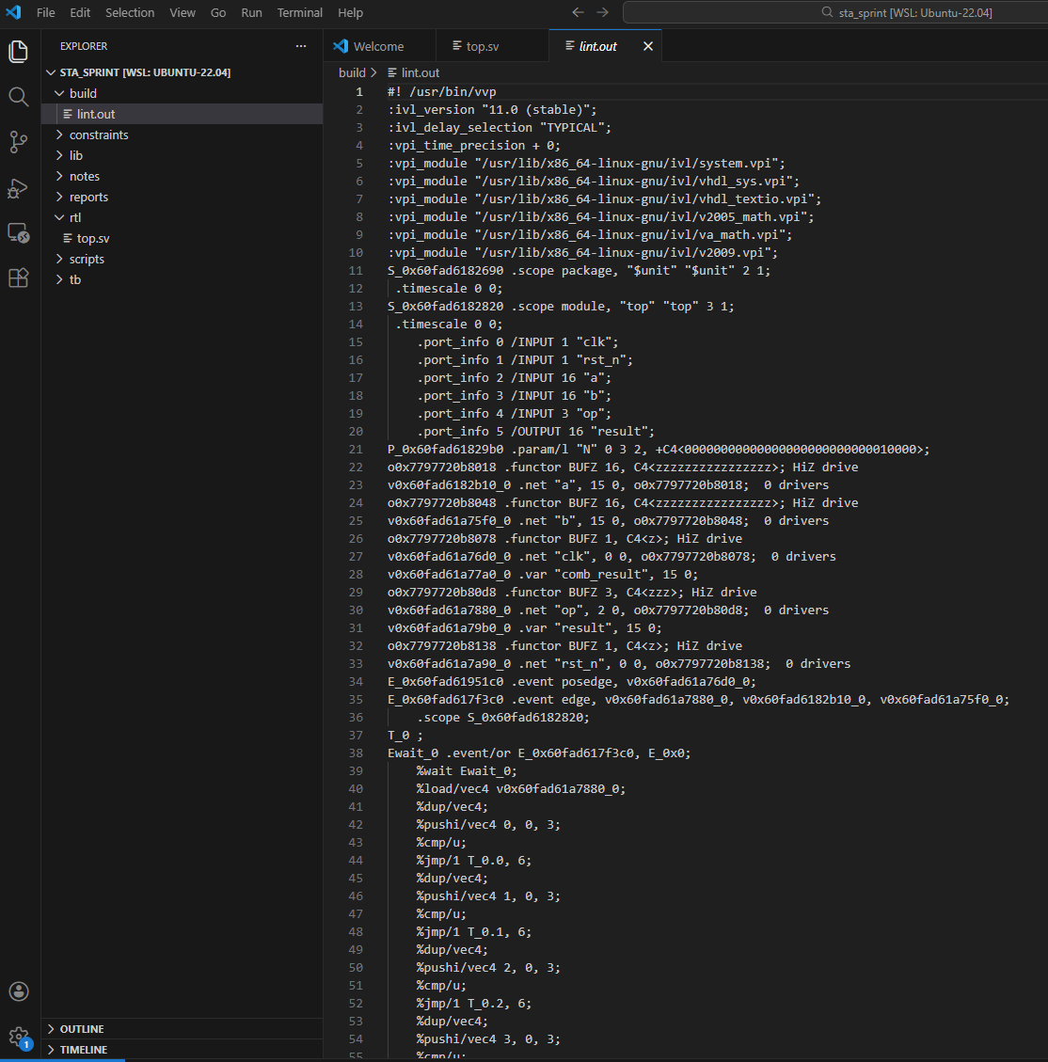
The successful generation of the above shown compiled output file (lint.out) confirms that the design contains no syntax errors, undeclared signals, or structural inconsistencies. The generated file represents the internal simulation bytecode, showing that the combinational and sequential logic blocks were correctly interpreted by the compiler. This step ensures the RTL is structurally sound before proceeding to synthesis and timing analysis.

(can you please explain this screenshot)
During RTL compilation with Icarus Verilog, a warning was issued indicating that the unique case qualifier is ignored. This is due to limited SystemVerilog feature support in the simulator and does not affect functional correctness.
The case statement is still compiled and executed normally and the unique keyword is simply treated like a normal case. This warning does not impact synthesis or timing analysis results.

Functional sanity simulation(explain what is means, why it is done and what the screenshots say
Functional sanity simulation is performed to verify that the design behaves correctly before moving to synthesis and timing analysis. It checks whether the RTL logic produces the expected outputs for given inputs, ensuring that the ALU operations (such as addition, subtraction, and logical functions) work as intended. This step helps detect logical errors, incorrect case handling, or reset issues early in the design flow. By confirming functional correctness first, we avoid wasting time debugging timing or synthesis problems that may actually be caused by basic logic mistakes.

Create testbench: tb/top_tb.sv

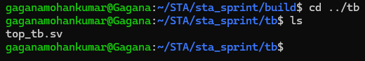

Run simulation and open waveform(Explain waveforms)
iverilog -g2012 -o build/sim.out rtl/top.sv tb/top_tb.sv
vvp build/sim.out
gtkwave build/waves.vcd
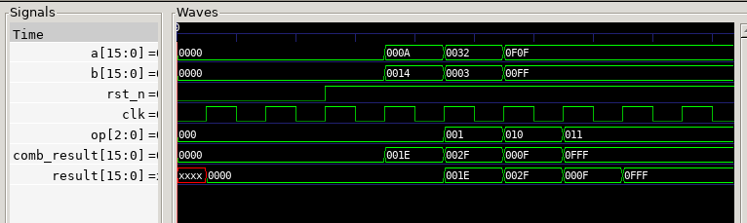
The simulation waveform confirms correct functional behavior of the synchronous ALU design.
Initially, the output result appears as unknown (XXXX) before reset is asserted, which is expected since the register is uninitialized. Once the active-low reset (rst_n) is asserted and then released, the output register is cleared to 0000, confirming proper reset operation.

The signal comb_result changes immediately when inputs (a, b, op) change, demonstrating correct combinational behavior inside the always_comb block. For example, when op = 000 (addition), the output corresponds to a + b (e.g., 000A + 0014 = 001E). When op = 001 (subtraction), the result updates accordingly (e.g., 0032 − 0003 = 002F). For logical operations such as AND, OR, and XOR, the computed values also match the expected bitwise results.

The registered output result updates only on the rising edge of clk, showing a one-clock-cycle delay compared to comb_result. This confirms correct sequential behavior from the always_ff block. Overall, the waveform verifies that arithmetic operations, logical operations, reset functionality, and synchronous output registration are all functioning as intended.
Terminal output showing build/waves.vcd created:
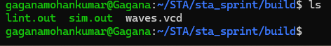

Synthesize with Yosys (RTL -> gate netlist)(explain why we do this and its significance)
Synthesis is a critical step in the digital design flow where the RTL description, written in Verilog or VHDL, is translated into a gate-level netlist composed of actual standard cells such as logic gates, flip-flops, and buffers. During this process, the synthesis tool maps the abstract behavioral description to technology-specific cells from a standard-cell library (e.g., Sky130 Liberty library). It also performs optimizations to meet design constraints related to timing, area, and power, ensuring that the hardware implementation satisfies the intended performance goals.
Synthesis serves as the bridge between functional design and physical implementation. While RTL simulation verifies logical correctness, synthesis produces a structurally realistic hardware representation that includes real gate delays and connectivity information. Static Timing Analysis (STA) must therefore be performed after synthesis, as accurate timing evaluation depends on the actual cell delays, setup/hold characteristics, and path information defined in the technology library. Without synthesis, timing analysis would rely only on idealized behavioral models and would not reflect real hardware performance, making any timing conclusions unreliable.
Create scripts/run_yosys.ys
cat > scripts/run_yosys.ys <<'EOF'
read_liberty -lib lib/sky130_fd_sc_hd__tt_025C_1v80.lib
read_verilog -sv rtl/top.sv
synth -top top
dfflibmap -liberty lib/sky130_fd_sc_hd__tt_025C_1v80.lib
# Map to Sky130 standard cells (uses the liberty file)
abc -liberty lib/sky130_fd_sc_hd__tt_025C_1v80.lib
opt clean
write_verilog -noattr build/top_synth.v
stat
EOF
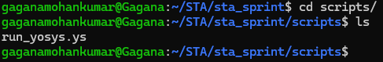

Run Yosys and capture logs and netlist (can you also provide screenshot of log file and explain your observations)
yosys -s scripts/run_yosys.ys | tee reports/yosys_stat.log
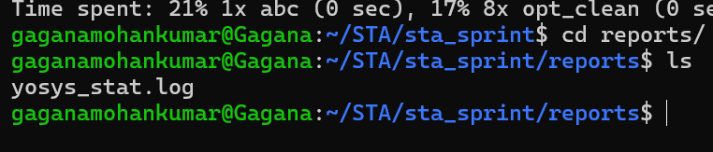
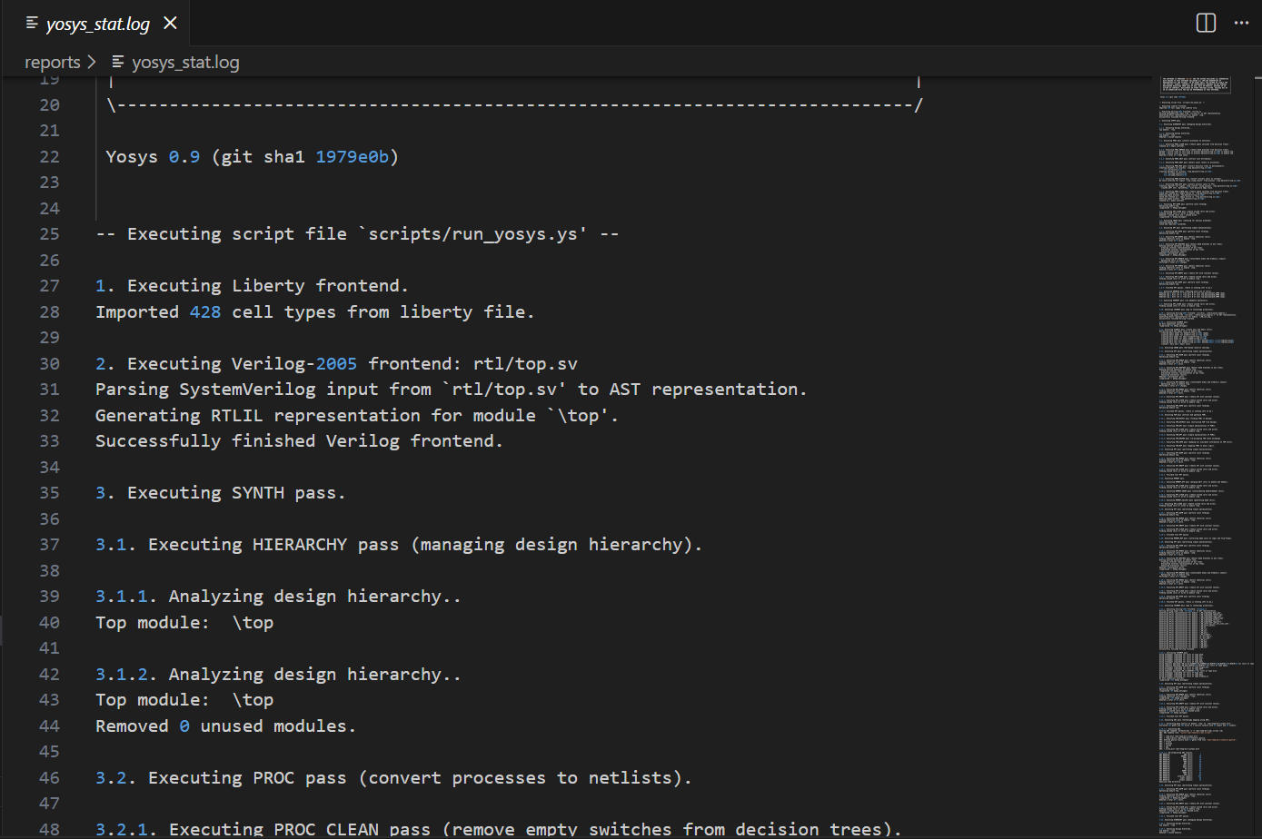
The Yosys synthesis log serves as a comprehensive record of the synthesis process, capturing each step from reading the HDL design to generating the optimized netlist.
It begins by reporting the successful parsing and elaboration of the design files, including the identification of all modules, their hierarchy, and interconnections. During the synthesis, the log tracks various optimization steps, such as constant propagation, logic simplification and retiming, providing insights into how the design is being optimized for area, speed, and resource usage.
If technology mapping is performed, the log details how the RTL logic is mapped to the target technology primitives, including statistics on the number of combinational and sequential elements before and after mapping. The log also highlights warnings or errors, such as unconnected signals or unsupported constructs, which are crucial for debugging the design.
Finally, the Yosys log provides a summary of the synthesized design, including resource utilization, hierarchy information, and netlist statistics, making it an essential reference for estimating area, timing, and overall design quality before proceeding to further stages like placement, routing, or verification.
Quick netlist sanity check(also please explain why you are doing this step and what you found)

After synthesis, a netlist sanity check is performed to ensure that the generated netlist is correct, complete, and ready for downstream stages such as simulation, placement, or routing. This check verifies that:

All modules from the original RTL are correctly instantiated.

All nets and ports are properly connected.

There are no combinational loops or floating signals.

Flip-flops, latches, and other sequential elements are correctly inferred.

Performing this check helps catch errors early that could lead to functional or timing failures in later stages, making it an essential step in the design flow.
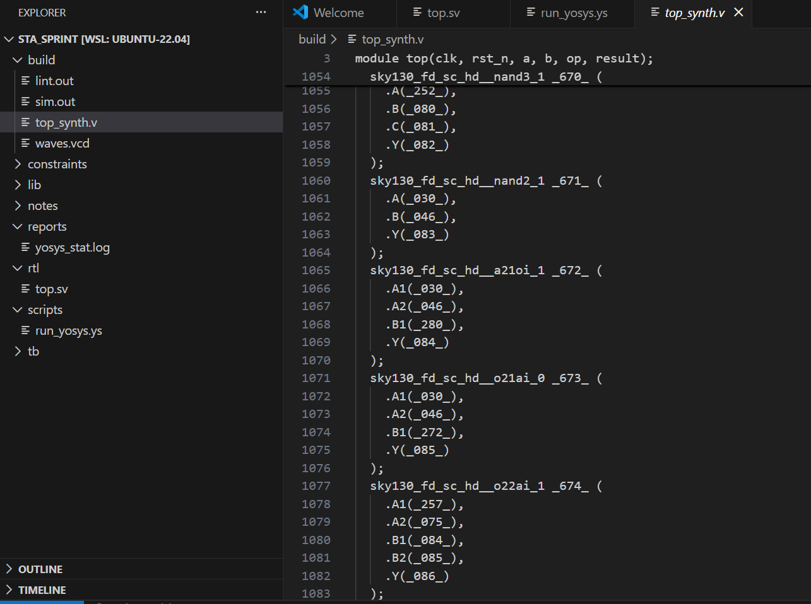 build/top_synth.v output showing the netlist exists

The synthesized netlist .v file contains a gate-level representation of the design, which is different from the original RTL. Key observations include:

- Module definitions and hierarchy: Top-level module along with instantiated submodules.
- Primitive gates and cells: Logic is expressed using technology-specific primitives (e.g., AND, OR, INV, DFF).
- Net and wire connections: Explicit wiring between gates and modules.
- Port definitions and connections: Mapping of input/output ports from RTL to gate-level signals.
- Optimized logic: Some high-level constructs (like if statements or case blocks) are replaced by equivalent gate-level structures.

This netlist is critical for functional verification, timing analysis, and physical design, as it accurately reflects the synthesized design that will be implemented in hardware.
Write constraints (SDC) - baseline + experiment(explain the constraints and its purpose)
create_clock: Defines a clock signal in the design along with its period and waveform. This is essential for the synthesis and timing tools to know the operating frequency of the design.
set_clock_uncertainty: Accounts for variations in the clock signal, such as jitter or skew between different clock domains, helping timing analysis tools to be more conservative and realistic.
set_input_delay: Specifies the delay of signals arriving from external sources relative to a clock. This helps the tool verify that input signals arrive in time for correct sampling by flip-flops.
set_output_delay: Specifies the expected delay of signals leaving the design to external loads relative to a clock. This ensures that outputs meet timing requirements for the next stage or interface.
set_driving_cell: Defines the characteristics of the cell driving a net, such as strength and delay. This allows accurate delay calculation during timing analysis.
set_load: Specifies the capacitive load connected to a net or output. This is important because higher loads increase delay, so the tool can calculate realistic signal propagation times.

Create the baseline constraints file
constraints/top_base.sdc with comments visible:
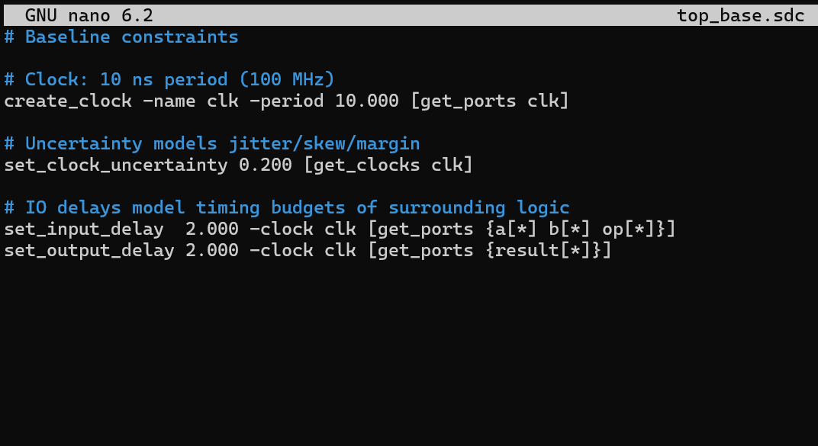

Create the tight constraints file(can you please explain the constraints)
file saved and visible in VS Code:
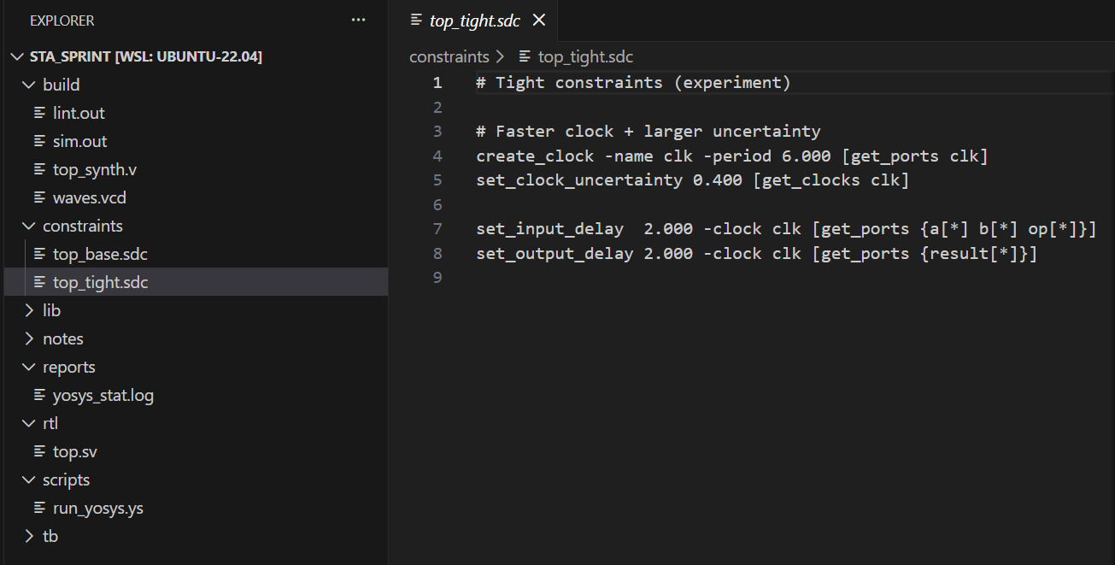

Run with OpenSTA (simulation) and save logs

Create scripts/run_sta.tcl

Run STA (baseline) and capture log
sta scripts/run_sta.tcl | tee reports/sta_base.log
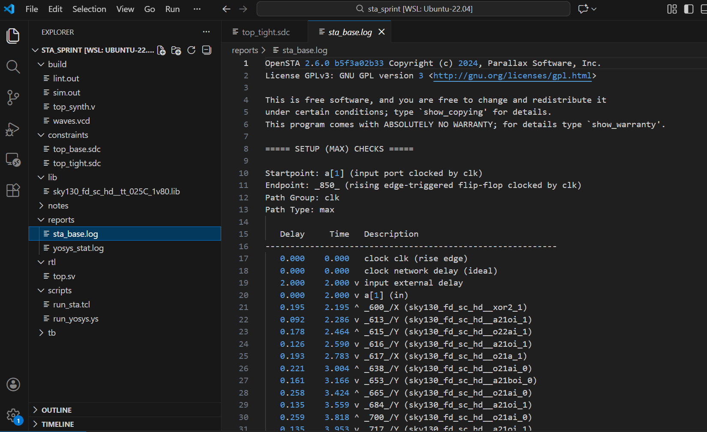(can you explain the output)

worst slack 4.47
worst slack 1.98
tns 0.00

Run STA (tight) and capture log
sta scripts/run_sta.tcl | tee reports/sta_tight.log
worst slack -3.78
worst slack 1.85
tns -55.05

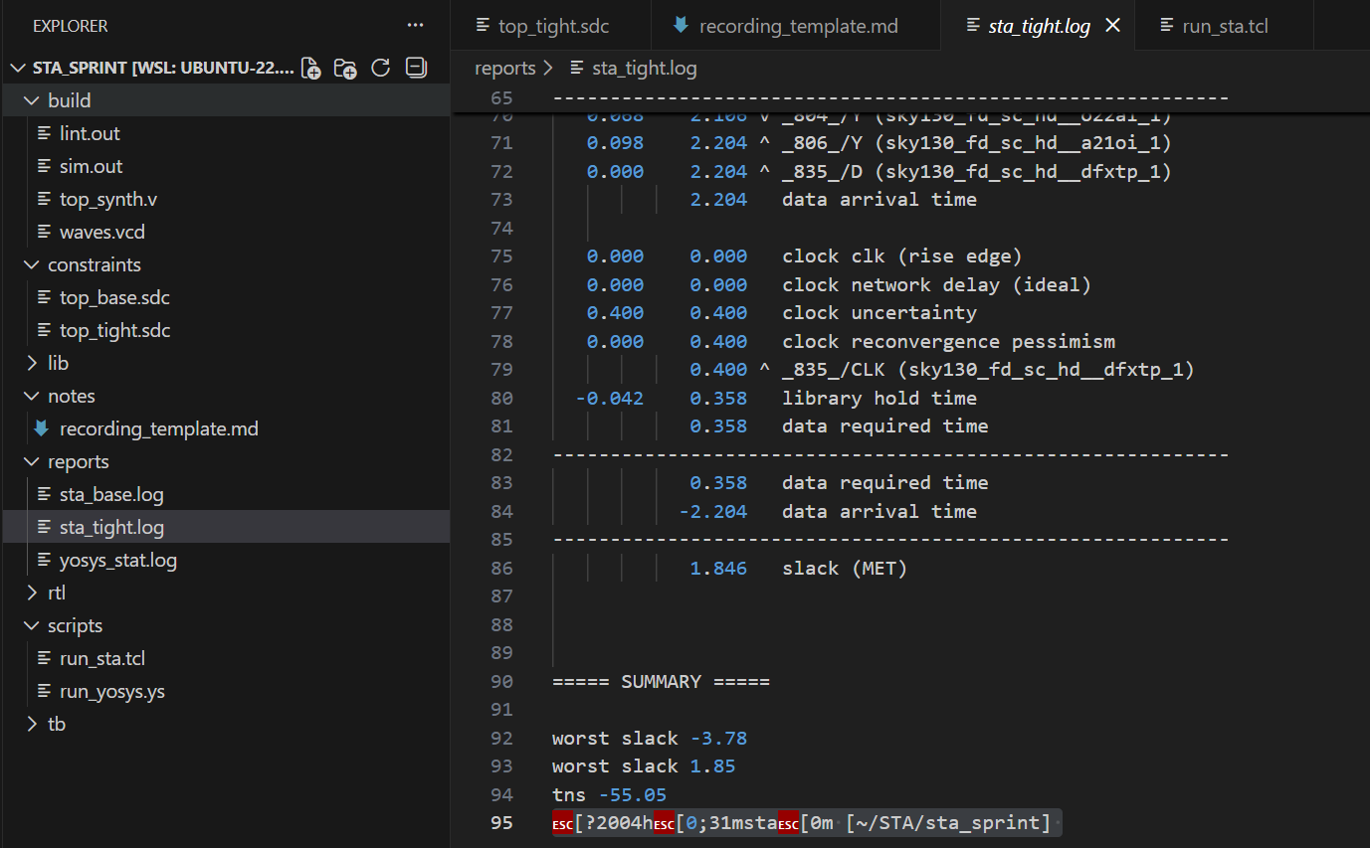

WNS/TNS summary lines and experiment table in recording_template.md
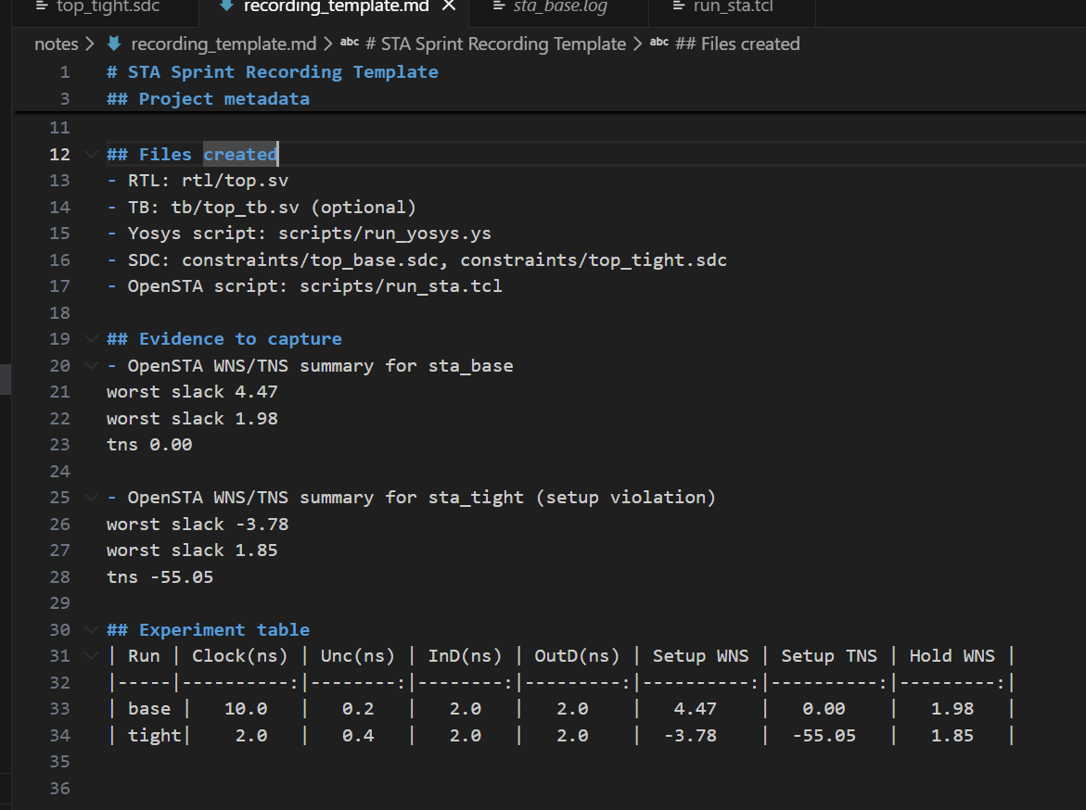
Static Timing Analysis was first performed using baseline timing constraints, under which the design met both setup and hold timing with positive slack of 4.47 and 1.98 respectively. When tighter constraints were applied by reducing the clock period to 2ns and increasing clock uncertainty to 0.4, the design exhibited degraded setup slack, with the Worst Negative Slack (WNS) becoming negative 3.78 and contributing to a non-zero Total Negative Slack (TNS). Hold timing remained met in both cases, indicating that the minimum data path delays were sufficient even under stricter conditions.

Extract the worst setup path (max)
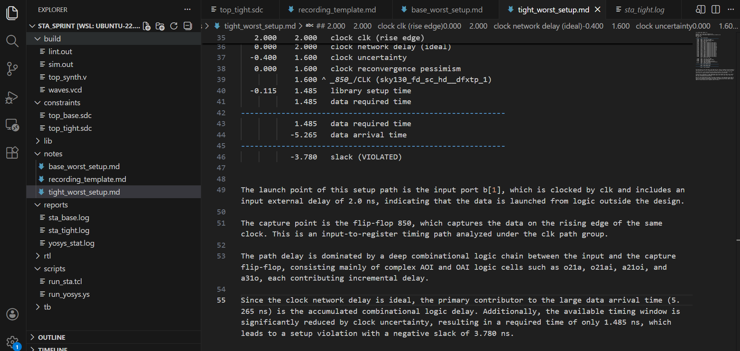
The worst setup path in the design is an input-to-register path from the input port b[1] to the flip-flop 850. This path is critical because it passes through a deep chain of combinational logic, primarily consisting of complex AOI and OAI gates used in ALU logic computation. The large accumulated combinational delay, combined with reduced available time due to clock uncertainty, causes this path to violate setup timing under tight constraints, making it the primary limiting factor for the maximum operating frequency of the design.
Extract the worst hold path (min)
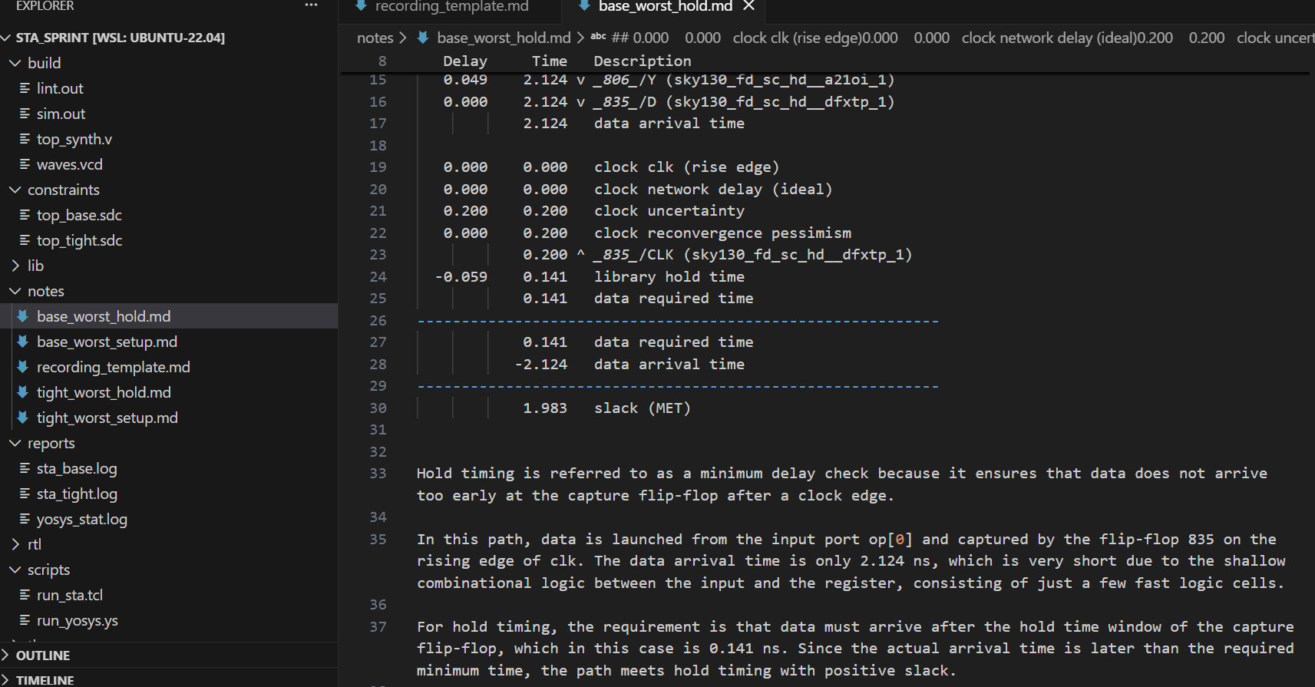
Hold timing is referred to as a minimum delay check because it ensures that data does not arrive too early at the capture flip-flop after a clock edge.

For hold timing, the requirement is that data must arrive after the hold time window of the capture flip-flop. Since the actual arrival time is later than the required minimum time, the path meets hold timing with positive slack.

Hold violations typically occur when data paths are too fast, and they are commonly fixed by intentionally adding delay to the data path, such as inserting delay buffers, using higher-delay cells, or increasing routing delay, rather than modifying the clock period.

You have not answered some of the questions so please do check if you have explained everything that you are doing, when you started implementation it was almost like you have followed the steps and placed everything going forward, rather than explaining what to do while you are doing it
Design Overview

The design implemented is a small arithmetic logic unit (ALU) that performs basic arithmetic and logical operations based on control inputs. A testbench was used to functionally verify the ALU before and after synthesis. The design contains a critical path because certain ALU operations require multiple levels of combinational logic between inputs and output registers, resulting in longer data propagation delays compared to other paths.

The design was constrained using a single clock with a defined clock period to model the target operating frequency. Clock uncertainty was applied to account for clock jitter, skew, and timing margin, reducing the effective time available for data propagation. Input and output delays were specified to model the interaction between the ALU and surrounding logic, representing the time taken for external logic to launch inputs and capture outputs. These constraints allow the Static Timing Analysis to reflect realistic system-level timing behavior rather than ideal conditions.

One possible improvement to address the critical path is to introduce pipelining within the ALU, splitting the long combinational logic into multiple stages separated by registers. This would significantly reduce the delay of each stage and improve setup timing, allowing a higher clock frequency. However, this approach increases the number of registers, leading to higher area and power consumption, and also increases the overall latency of the ALU by adding extra clock cycles to produce the final result.

Overall, this analysis demonstrates how timing constraints, combinational logic depth, and clock uncertainty interact to determine the performance limits of a synchronous digital design.

